Airline Passenger Satisfaction

PITCH

Viviane:

Are you looking to boost passenger satisfaction and increase profits for your airline? Look no further than your business class passengers and potential business class passengers. With 70% of your total profit coming from these passengers, it's clear that they're crucial to your success.

Evidence shows that Individuals traveling for work are significantly less satisfied in economy class than those traveling for personal reasons. However, business travelers are more satisfied in business class than those traveling for personal reasons. This suggests that the needs of work travelers are not being fully met in economy class, but upgrading to business class offers a better experience.

To understand how to better serve these valuable customers, we've analyzed the 'US Airline passenger satisfaction' dataset from 2015. This dataset includes ratings of 14 air travel services as well as additional information about each passenger, such as their class and type of travel. The 14 ranked services include airline backoffice services, airport services, in-flight-services and on-board-infrastructure.

Cosima:

Our aim is to identify which services should be marketed to corporate travelers flying economy class to convince them to upgrade to business class. By doing so, we can enhance passenger satisfaction and drive profits for your airline.

To determine which airline services to market, we compared passenger satisfaction of the airline services between economy and business class. We evaluated 14 different services and calculated the percentage of passengers who were satisfied or very satisfied (rated 4 or 5 on a scale) in this two classes. Then, we compared the proportions between economy and business class for each service to identify the largest differences.

Folie 2:

Nina:

We presented our findings in a plot, where services are ranked by the size of the difference in satisfaction levels between economy and business class. The services at the top in green indicate the greatest differences. These services are the ones that should be marketed to corporate travelers in economy class to convince them to upgrade to business class. As we can see, marketers should focus on online boarding, onboarding service and baggage handling, but not on Time Convenience, Gate Location and Wifi - here shown in red.

Now it’s your turn to act upon our findings and improve the satisfaction of your airline passengers!

Limitations? Not in the final presentation but in the 10min presentation

* We haven’t considered all external and internal confounding variables (such as external: socioeconomic status, purchasing power; and internal: flight distance, what the different services entail)
* The Validity of the questionnaire cannot be assessed

PLOT – CHANGES:

**Plot:**

* Capitalize the names (first letter)
* 3 highest delta-line = green
* 3 lowest delta-line = red
* Business = vierrecke economy = rund
* Label business and economy rechts und links setzen
* 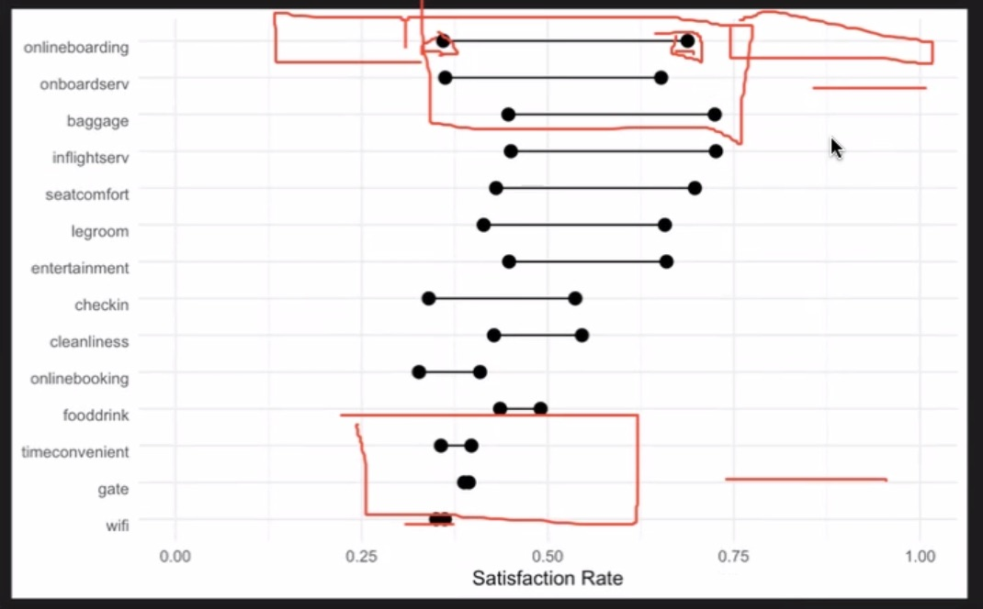

NEXT MEETING:

Prepare two slides:

1. Cover slide with an image covering the whole page, title, names 🡪 set the context, pitch (motivation, aim)
2. Plot, title of the plot (e.g: “Marketers should focus on …. But not …”) 🡪 answer research questions

(NA’s for each satisfaction variable: between mind. 0% ; max: 5.14% (mean: 0.8%) )